Career Competencies Reflection Assignment

Purpose: The National Association of Colleges and Employers identifies several key career readiness skills that employers are looking for:

- Critical Thinking/Problem Solving
- Oral/Written Communications
- Teamwork/Collaboration
- Digital Technology
- Leadership
- Professionalism/Work Ethic
- Career Management
- Global/Intercultural Fluency

These skills and competencies resonate across UO’s Core Education, as also in the learning objectives and experiences in this course. This assignment is designed to help you reflect on how this course has helped you develop and practice many of these skills, and most importantly, to help you articulate these competencies in the context of relevant careers.

- List the skills that this course allowed you to practice (you may also choose to include other skills from research methods and data analysis time management). Are there any areas where you think your strength grew particularly this term?

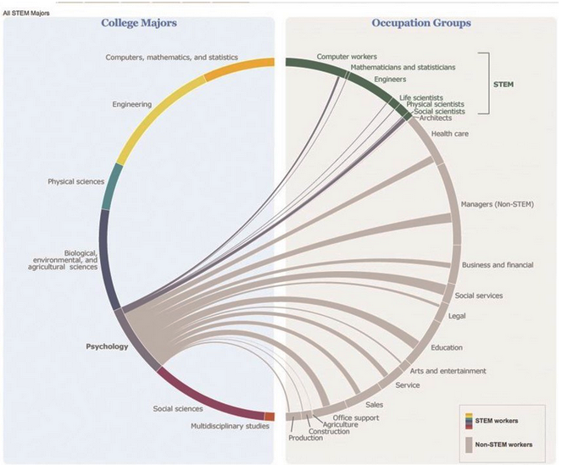
- Psychology is relevant to a broad array of careers. Some of these are included in this image and others are discussed in each chapter of your textbook (see PUTTING PSYCHOLOGY TO WORK section in each chapter).

Briefly (in about 100 words) describe how what you've learned and practiced in this course may be relevant to the career(s) you are most interested in at this time (yes, career choices develop and change throughout college and beyond, but it is a good idea to reflect on how your learning related to your current goals!)

- Now that you have thought of some skills you have developed and practiced, it's time to articulate your in-class experiences and strengths for your resumes, or potential employers (you could talk about it in your next internship interview!).
Write one bullet point, or a couple of sentences, here about one such skill/competency as you would in your resume (you should put it in your resume too!)

